Section 5 : welcome to Pankaj
- Pankaj Plywood  -> Explore More

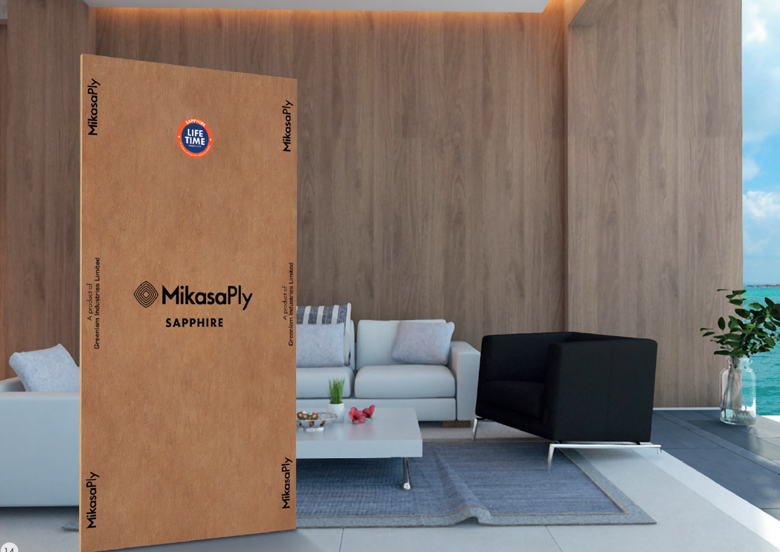

Reference website:
https://www.centuryply.com/plywood

- Decor point

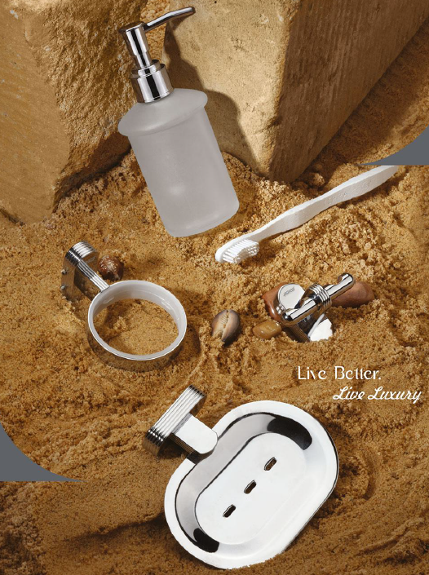

Category:

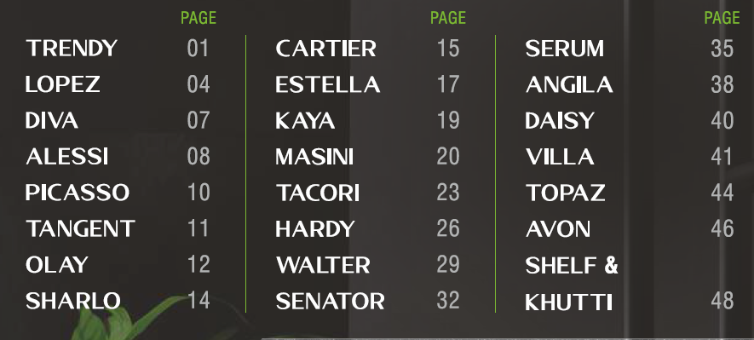

- Faber

Reference website:
https://faberindia.com/

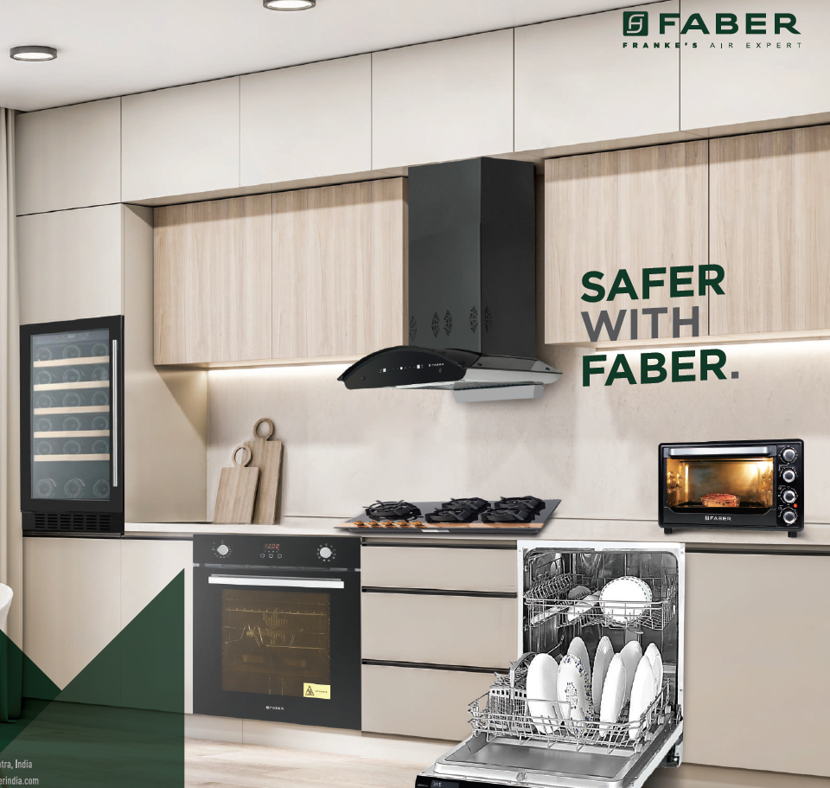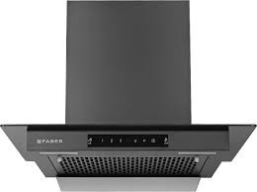

Category:
- Chimney
- Microwave
- Dishwasher

https://faberindia.com/

Section 7:
- Limocoat - https://limocoat.com/

- Colortek

